REVOLUTIONARY THERAPY FOR CHILDREN AND ADULTS SUFFERING FROM THE EFFECTS OF SENSORY PROCESSING DISORDERS, ADHD, LEARNING DIFFICULTIES AUTISM AND STROKE, PARKINSONS AND OTHER DISORDERS
Overview of Service
Anneke Krüger, Occupational Therapy now offers Interactive Metronome Training to Improve Cognitive, Behavioral, Social and Motor Skills
The therapy has proven to improve speech/communication, coordination and learning, in adults and children suffering from a number of conditions including ADHD and Autism, as well as the physical effect of stroke and Parkinson’s. Interactive Metronome® (IM) is a computer-based technology that encourages users to match the computer’s rhythm, thereby improving their internal sense of timing, An increasing amount of scientific evidence demonstrates that the brain’s internal clock is integral in the development and maintenance of many cognitive, behavioral, social and motor skills.
Unfortunately, when the brain’s timing malfunctions due to a medical condition—such as Attention Deficit Hyperactivity Disorder (ADHD) or Autism—or is disrupted by a stroke, a traumatic brain injury, or even a degenerative disease like Parkinson’s, the associated physical, mental and emotional symptoms can be difficult to overcome. Locally, Anneke Krüger Occupational Therapy, now offers Interactive Metronome’s ‘rhythmic and movement training exercises to improve functioning in children and adults.
“We’ve always known that timing in the brain affected a wide variety of conditions, but until Interactive Metronome we did not have a single therapy that could improve timing in both children and adults. Both our therapists and patients find Interactive Metronome to be a challenging, yet fun therapy that keeps their attention, and produces significant results. Interactive Metronome can form an integral part of the Occupational Therapy process for clients with a variety of diagnosis and areas of difficulty.” Anneke Krüger

Interactive Metronome involves the principles of the traditional musical metronome, combined with the precision of a personal computer to create engaging interactive training exercises. The program uses head phones along with hand and foot sensors to coordinate movements to computer-generated musical beats. Like training wheels on a bicycle, a patented auditory guidance system progressively challenges participants to improve their motor planning, sequencing and rhythmic timing performance.
Interactive Metronome® training is currently available in Centurion at Irene Occupational and Speech Therapy (main practice and Cornwall Hill School) by Anneke Kruger. IM home training (please discuss with your therapist) can also be done in with IM-Home. For more information, visit www.interactivemetronome.com or www.imhome.org.

MORE ABOUT

THE GOALS OF
- IMPROVE NEURAL TIMING – IMPACTS SPEECH, LANGUAGE, COGNITIVE, MOTOR & ACADEMIC PERFORMANCE
- BUILD MORE EFFICIENT & SYCRONISED CONNECTIONS BETWEEN NEURAL NETWORKS
- INCREASE BRAIN’S EFFICACY, PERFORMANCE AND ABILITY TO BENEFIT MORE FROM OTHER REHABILITATIONS AND INTERVENTIONS

WHY IS TIMING IMPORTANT?
The human brain has an internal clock that processes time from microseconds to several hours. Our ability to locate where a sound is coming from, then understand the speech of others, to read and comprehend, and the move in a coordinated fashion is all a matter of precise timing & synchronization of neural networks in the brain.
When we perform any cognitive, communicative, sensory or motor activity (like having a conversation or paying attention to the teacher in class) we are using multiple parts of the brain at the same time. These different parts of the brain are called neural networks. Neural networks are connected to each other by bundles of nerves that are called white matter tracts. These tracts act like super highways sending signals back and forth between brain networks. The more synchronized the signals are along these white matter tracts, the more efficient the brain is working and the better the person performs on cognitive, communicative, sensory, and motor activities.
Interactive Metronome improves synchronization of neural networks and increases the efficiency of communication between neural networks along critical white matter tracts. Researchers have also identified a problem synchronization in the brain in individuals with ADHD, Autism, Dyslexia and other reading disorders, Stroke, Traumatic Brain Injury, Tourettes and other conditions.
Poor timing influences:
- Attention
- Auditory processing
- Sensory processing
- Self-control
- Mental processing speed
- Speech & language
- Reading
- Memory & learning
- Handwriting
- Coordination & balance

THE SCIENCE BEHIND IT
- The ability to tap consistently to a beat is directly related to a person’s ability to process speech sounds, read and learn.
- There is considerable evidence that children with speech, language & reading disorders also have fine & gross motor impairments. These children tend to have much greater difficulty with timed or rhythmic auditory-motor activities, like clapping in sync with a steady beat (as you do during Interactive Metronome training), than children who are developing speech, language and reading skills normally. This is because the same pathways in the brain are used for processing and motor skills. In order to improve auditory and language processing skills, you must engage the auditory & motor systems at the same time (like clapping your hands to a steady beat).
- EEG studies conducted before & after IM training showed rewiring of the brain (frontal-parietal cortex) & re-establishment of critical white matter tracts that connect important neural networks.

WHAT MAKES IT DIFFERENT?
- Research supporting IM
- Measurable, objective, real time feedback and high repetitions
- Real-time feedback for timing after each hit so child knows if he was too fast, too slow, or just right – this leads to better internal timing & synchronization in the brain.
- A child completes 10s of 1,000s of repetitions over the course of training – this encourages lasting changes in brain function.
- Training is individually tailored for each child’s needs with settings that are adjustable to make training easier or more challenging.
- IM includes games to make training more fun!
- Other modalities such as video games does not measure timing, feedback is not given to the millisecond timing range, improvements are only game specific, little or no bilateral and lower limb involvement and has low repetitions.

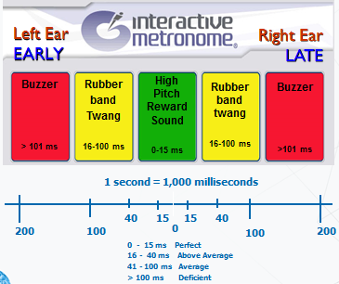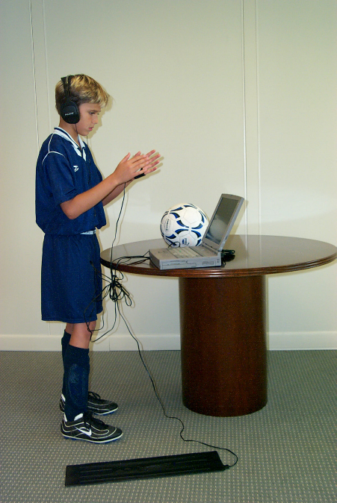

WHO CAN BENNEFIT FROM AS PROVEN BY RESEARCH?

- Autism Spectrum Disorders
- Sensory Processing Disorder
- Auditory Processing Disorder
- Attention Deficit/Hyperactivity Disorder
- Developmental Coordination Disorder
- Language-Learning Disorders
- Dyslexia and Other Reading Disorders
- Executive Function Disorder
- Agenesis of the Corpus Collosum
- Apraxia of Speech/Fluency Disorders
- Traumatic Brain Injury
- Cerebral Palsy
- Concussion/mTBI
- Brain Tumor
- Stroke
- Sports & Performance Enhancement
WHAT BENEFITS DOES IT HOLD FOR MY CHILD?

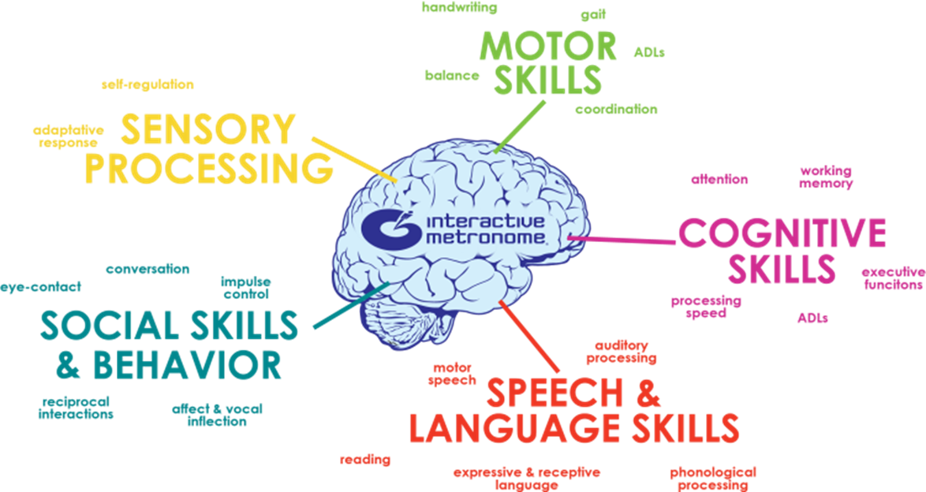

Why Does Interactive Metronome Impact So Many Abilities?
An explanation for this can be found in the literature on Domain-Specific Vs Domain-General learning mechanisms.
A domain-specific learning mechanism is one that allows you to acquire over-learned behaviors that become automatized – at first you must be cognitively engaged, but over time you learn the skill and can do it without thinking about. Like riding a bike or driving a car. This comes under the control of a narrow set of domain-specific brain mechanisms that allow you to learn a specific task, but improving on that specific task does not lead to improvement in other skills like attention and reading.
On the other hand, a domain-general learning mechanism is one that crosses multiple domains. If you can tap into that domain-general mechanism and effect it with some type of training or exercise, it leads to improvement across several areas of cognitive, communicative, sensory, and motor performance. There is convincing evidence from numerous peer reviewed studies that the domain-general mechanism involves the synchronization of neural networks via white matter tract connections & speed of processing, particularly within the prefrontal-parietal cortex.
As mentioned, EEG findings show that IM training impacts this critical domain-general learning mechanism resulting in remodeling of white matter tracts & improved neural synchronization, particularly wtihin the prefrontal-parietal cortex.

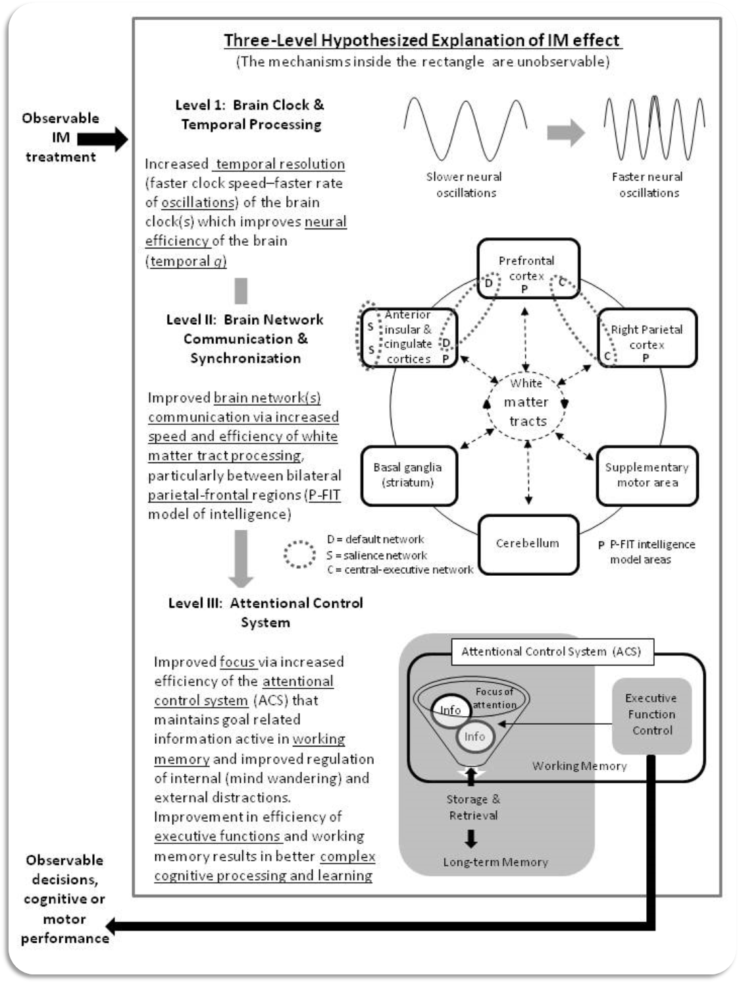

WHERE DOES IT FIT IN THE OCCUPATIONAL THERAPY SCOPE AND TREATMENT PLAN?
Occupational Therapy within the scope of pediatric practice is concerned with the functional capabilities needed for a child to excel in all areas of occupational performance, including school and academic activities, leisure/play and sports, activities of daily living, sleep and social proficiency. Occupational Therapy addresses sensory, motor, perceptual, cognitive and emotional components relating to poor or underachievement in their daily occupations.
As address so many of these components, it can form an integral part of Occupational Therapy treatment.
is not viewed as a “stand alone” approach in Occupational Therapy treatment and should be used as part of a greater treatment plan also involving other treatment approaches (such as Ayers Sensory Integration, NDT, perceptual training etc.) appropriate to the child’s individual difficulties and needs. Thus each client’s IM training plan will be different and also be implemented at a different stage in therapy. A typical IM training session may also include strategies from other treatment approaches (such as sensory regulation inputs etc.) to obtain optimal results in the training. IM can be especially beneficial when the need is in:
- Bridging the gap between conventional Ayers Sensory Integration® intervention and cognitive learning and remediation therapies.
- Children with severe and multiple difficulties that needs additional more intensive intervention to regular therapy.
- To support the treatment of difficulties addressed by other therapies (such Speech and Language intervention)
- Clients that have received individual therapy in the past and are in need of follow up support

As is used as a treatment modality within the scope of Occupational Therapy, assessment and treatment is billable under Occupational Therapy services from medical aids.

HOW IS THE TRAINING IMPLIMENTED
(FREQUENCY, INTENSITY AND DURANTION)?
Clients are first assessed along the following criteria before recommendations on the training programme is made:
- Age, diagnosis and referring difficulties
- Expected outcomes of the intervention
- Previous and current therapies and progress made in therapies
- Previous IM Training as part of Occupational Therapy
- Previous Assessment results in Occupational Therapy/ Speech and Language etc.
- A full IM Assessment (specific assessments will be chosen according to the referring problems)

Intervention is then planned according to the following and discussed in the post evaluation feedback
- Note: In certain cases, upon reviewing initial evaluation results, IM training may need to be preceded by a period of individual Occupational Therapy intervention using intervention such as Ayers Sensory Integration therapy.
- The “dosage of training” will be determined by the outcome of the assessments. Repetition is required in order to make lasting, functional changes in the brain. Performing “a little” IM here or there or for a short period of time will not lead to effective functional neurological change.
- Typically it will be at least:
  - Two x 10 session (10 days) intensives with a 6-8 week break
  - One x 15 session (15 days) intensive with a possible second intensive after 8-12 weeks.
- AT LEAST 3x/week (optimal frequency is 5 times per week) – session of 45 minutes to an hour (60 minutes is preferable) working to do at least 3600 repetitions in a session
- A post performance measure at the end of every session will track progress throughout and will be (either electronically or verbally) conveyed to the client and parents.
- The content of training will be determined by the areas of difficulty as well as ongoing progress measured week by week. Intervention is conducted in 4 phases and the pace of progress through the phases is entirely dependent on the client’s individual progress.
- IM home option can be considered if clients have already had intensive individual direct IM training and need to continue with the program at home or in cases where clients reside in outlying areas and cannot attend sessions at the practice.

Upon completion of the IM training intensive:
- A full re-assessment will be conducted and a feedback with results given.
- Recommendations will then be given on the
- Need for further intensives and the goals
- Time lapse between intensives
- Need for additional therapies or continuation of conventional Occupational Therapy

PLEASE CONTACT US FOR FURTHER INFORMATION

